Webpage Portfolio Diary

Miguel Silva

W1945895

Seminar

Week 1: 29th September 2023

Implemented the barebones of the website for the Home Page

* Nav Bar
* Content
* Sidebar
* Linked my social media

Week 2: 5th October 2023

* Constructed the layout of the page using grid method
* Completed the CSS for the Side bar, Nav Bar, Body and Header

Summary:

I was able to successfully produce a linear gradient background for my header. I produced the CSS transition for the nav bar. Also added my own logo to the page. Managed to source my images for the social media icons. Created the hover effect for the icons so that they transition from 50% opacity to 100% opacity.

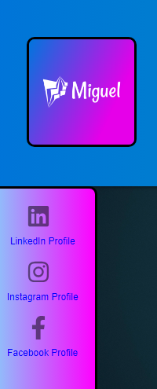 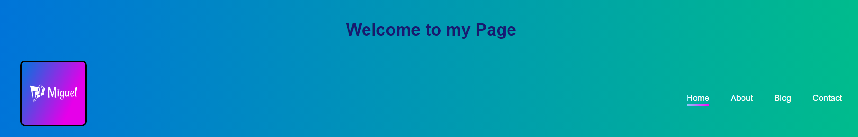

**HTML**

        <aside class="sidebar">

            <div class="social-icons">

                <a href="https://www.linkedin.com/in/miguel-silva-004b36250/" target="_blank">

                    <img src="https://raw.githubusercontent.com/MysticMigz/Personal-Website-Project/00cb553e6b4a11de5553084c6c774bed310e34b1/linkedin.svg" alt="LinkedIn">

                    <span>LinkedIn Profile</span>

                </a>

                <a href="https://www.instagram.com/miguelsilva5088/" target="_blank">

                    <img src="https://raw.githubusercontent.com/MysticMigz/Personal-Website-Project/00cb553e6b4a11de5553084c6c774bed310e34b1/instagram.svg" alt="Instagram">

                    <span>Instagram Profile</span>

                </a>

                <a href="https://www.facebook.com/profile.php?id=100002558094945" target="_blank">

                    <img src="https://raw.githubusercontent.com/MysticMigz/Personal-Website-Project/00cb553e6b4a11de5553084c6c774bed310e34b1/facebook-f.svg" alt="Facebook">

                    <span>Facebook Profile</span>

                </a>

            </div>

        </aside>

**CSS**

.sidebar {

  width: 140px;

  background: linear-gradient(90deg, lightskyblue, magenta);

  color: #fff;

  padding: 20px;

  text-align: center;

  display: flex;

  height: 100%;

  border: solid black;

  border-radius: 10px;

  grid-column: 1 / 2;

}

.social-icons a {

  display: block;

  margin-bottom: 15px;

  text-decoration: none;

  color: #fff;

}

.social-icons img {

  width: 30px;

  height: 30px;

  margin-right: 10px;

  opacity: 50%;

}

/* Added hover effect to the social icons */

.social-icons img:hover {

  transition: 1s;

  opacity: 100%;

}

.social-icons span {

  display: inline-block;

  font-size: 12px;

  color: blue;

  text-align: center;

  font-family: 'Poppins', sans-serif;

}

Week 3: 12th October 2023

Contact Form:

* Produced the content for the Form webpage
* Styled the Contact Form Page
* Implemented the Validity CSS

Implemented the validity pseudo class on the form with appropriate colour styling so that if its not correct it appears red, if correct it turns green.

Styled the boxes so that they are clear and easy to see.

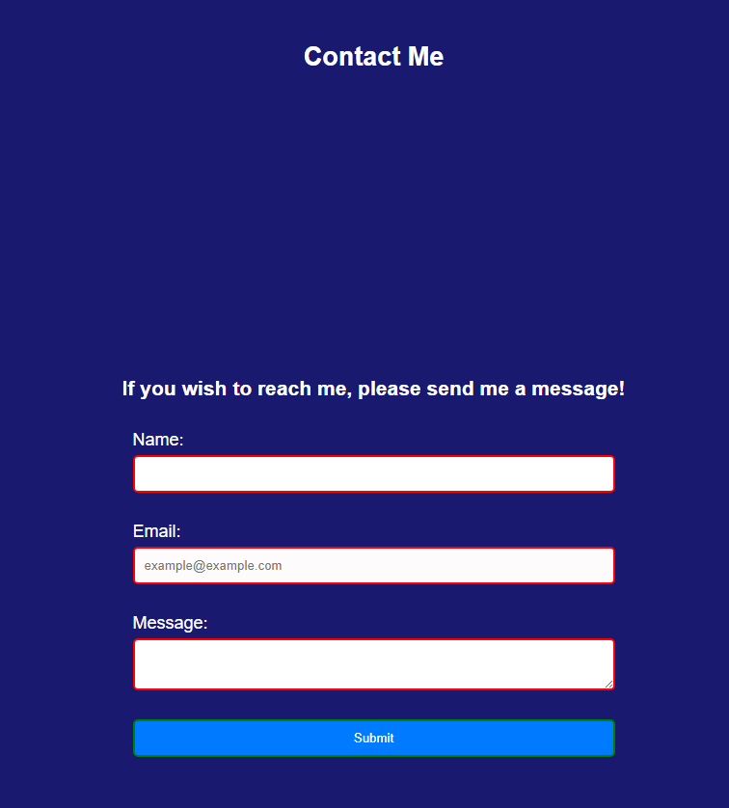

**HTML**

    <main>

        <!-- Contact Page -->

        <h2>Contact Me</h2>

        <section id="contact-form">

            <h3>If you wish to reach me, please send me a message!</h3>

            <form action="submit_form.php" method="post">

                <!-- HTML5 form elements for registration and messaging -->

                <label for="name">Name:</label>

                <input type="text" id="name" name="name" required>

                <label for="email">Email:</label>

                <input type="email" id="email" name="email" required placeholder="example@example.com">

                <label for="message">Message:</label>

                <textarea id="message" name="message" required></textarea>

                <input type="submit" value="Submit">

            </form>

        </section>

        <footer>

            <p>&copy; Miguel Silva 2023 Portfolio Website</p>

        </footer>

    </main>

**CSS**

/*----------------Contact Form Page------------------ */

/* Center the contact form section */

h2 {

  display: flex;

  flex-direction: column;

  align-items: center;

  justify-content: center;

}

#contact-form {

  display: flex;

  flex-direction: column;

  align-items: center;

  justify-content: center;

  min-height: 100vh;

}

form {

  display: flex;

  flex-direction: column;

  width: 100%;

  max-width: 500px;

}

label {

  margin-top: 10px;

}

input[type="text"],

input[type="email"],

textarea {

  width: 100%;

  padding: 10px;

  margin-top: 5px;

  margin-bottom: 20px;

  /* Space between the inputs */

  border: 1px solid #ccc;

  border-radius: 5px;

}

input[type="submit"] {

  width: auto;

  padding: 10px 20px;

  margin-top: 10px;

  border: none;

  border-radius: 5px;

  background-color: #007bff;

  color: white;

  cursor: pointer;

}

input[type="submit"]:hover {

  background-color: #0056b3;

}

Week 4: 19th October 2023

Blog Page

Implementing: The flip transformation on an image

Before: After:

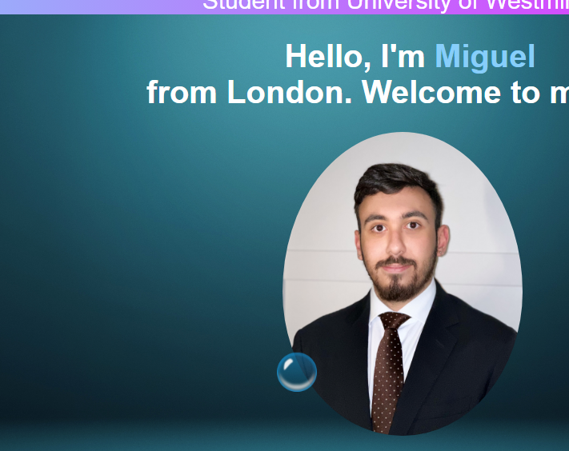 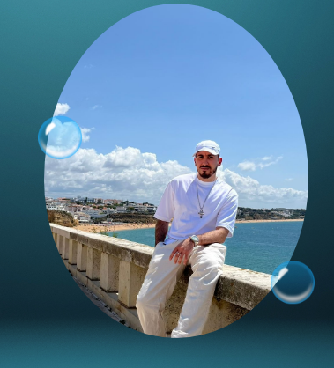

        <div class="container-content">

            <div class="header-text">

                <p>Student from University of Westminster</p>

                <h1>Hello, I'm <span>Miguel</span> <br> from London. Welcome to my Site!</h1>

            </div>

            <div class="flip-card">

                <div class="flip-card-inner">

                    <div class="flip-card-front">

                        <img src="https://github.com/MysticMigz/Personal-Website-Project/blob/main/suit2.png?raw=true" alt="Front Image">

                    </div>

                    <div class="flip-card-back">

                        <img src="https://github.com/MysticMigz/Personal-Website-Project/blob/main/1000001448.jpg?raw=true" alt="Back Image">

                    </div>

                </div>

            </div>

Week 5: 26th October 2023

Utilising the Nth term pseudo class  
Implemented the progression bar styling with the Nth child pseudo class

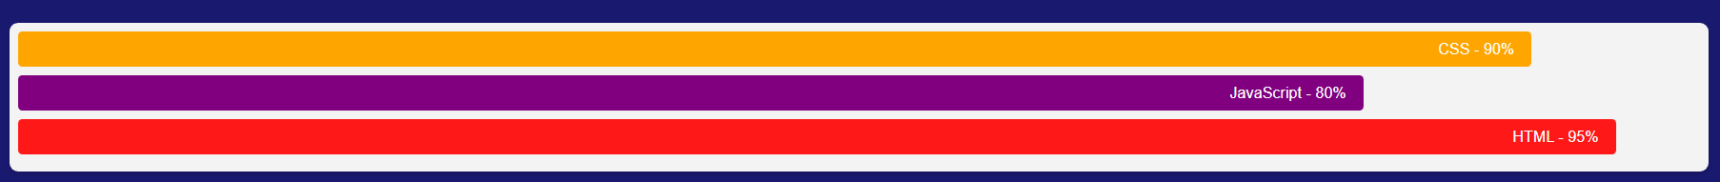

Week 6: 2nd November 2023

Media Responsiveness and Animations

Implemented all appropriate media queries for small, medium and large devices. Added the animation Key frames for the bubbles on my home page as they move from the bottom to the top slowly become opaquer until completely invisible.

Medium Device Screen – Name turns Green Small Device Screen – Name turns Red

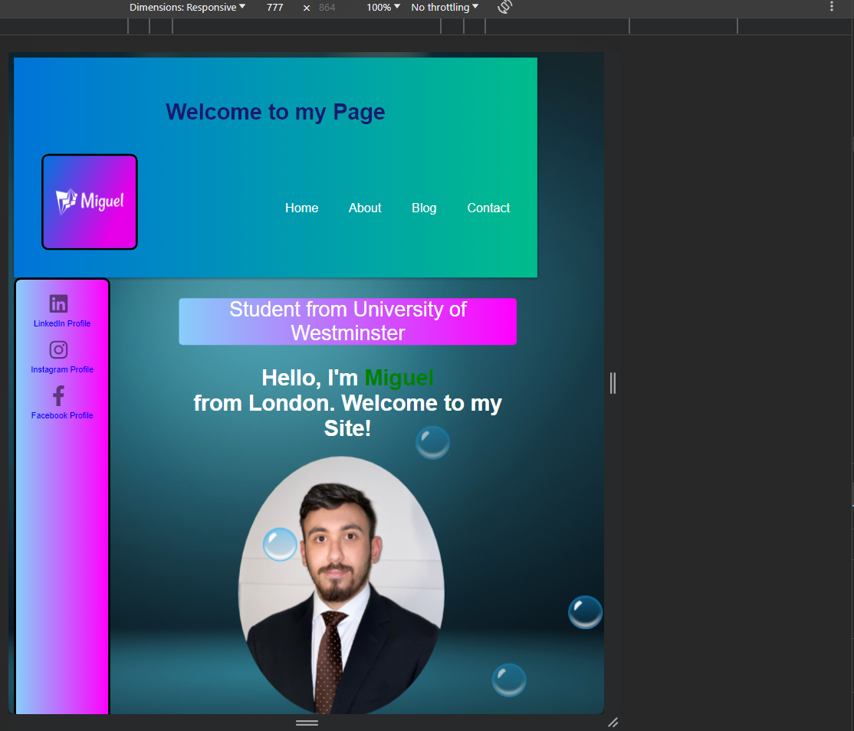 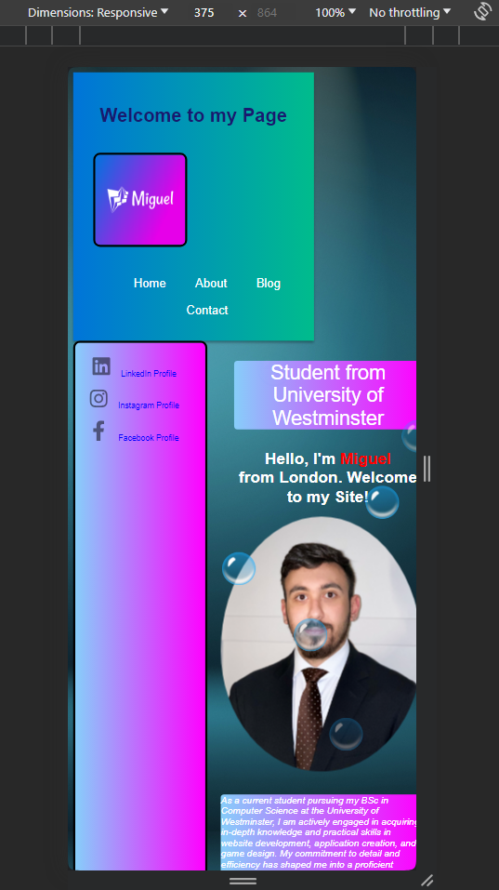

Large Device Screen – Stays LightSkyBlue

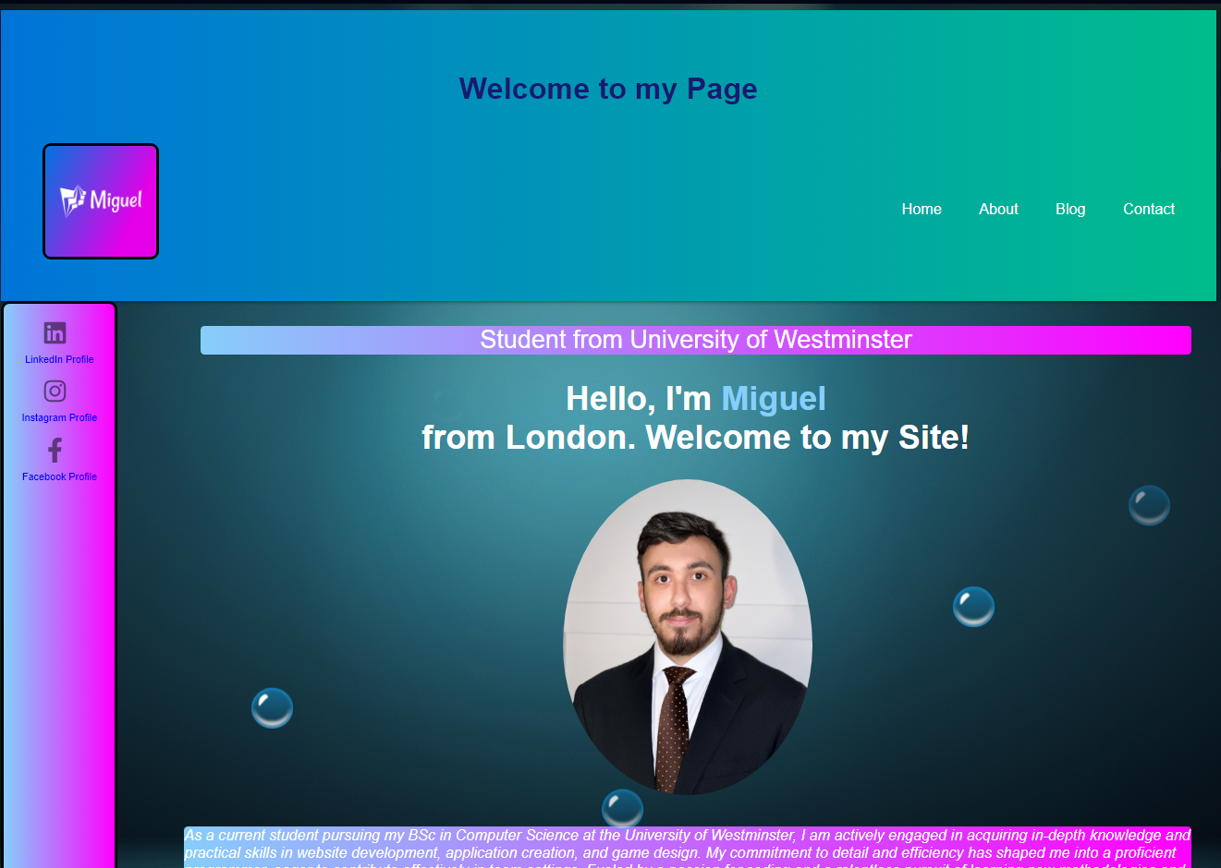

@media screen and (max-width: 768px) {

  .Full-Content {

    flex-direction: column;

  }

  .sidebar,

  .container-content {

    width: 100%;

  }

  .content-flex {

    flex-direction: column;

  }

}

@media only screen and (max-width: 600px) {

  /* Styles for small screens */

  body {

    font-size: 14px;

  }

  .container-nav nav ul {

    flex-direction: column;

  }

  .header-text h1 {

    font-size: 1.5rem;

  }

  article {

    font-size: 14px;

  }

  header,

  main,

  footer {

    padding: 10px;

  }

  .progress-container .progress-bar {

    font-size: 14px;

  }

  .header-text h1 span {

    color: red;

  }

}

@media only screen and (min-width: 601px) and (max-width: 1024px) {

  /* Styles for medium screens */

  body {

    font-size: 16px;

  }

  .container-nav nav ul {

    flex-direction: row;

  }

  .header-text h1 {

    font-size: 2rem;

  }

  article {

    font-size: 16px;

  }

  header,

  main,

  footer {

    padding: 20px;

  }

  .progress-container .progress-bar {

    font-size: 16px;

  }

    .header-text h1 span {

    color: green;

  }

}

@media only screen and (min-width: 1025px) {

  /* Styles for large screens */

  body {

    font-size: 18px;

  }

  .container-nav nav ul {

    flex-direction: row;

  }

  .header-text h1 {

    font-size: 2.5rem;

  }

  article {

    font-size: 18px;

  }

  header,

  main,

  footer {

    padding: 30px;

  }

  .progress-container .progress-bar {

    font-size: 18px;

  }

    .header-text h1 span {

    color: lightskyblue;

  }

}

**Animations Keyframes:**

@keyframes bubble{

   0%{

    transform: translateY(0);

    opacity: 0;

  }

    50%{

    opacity: 1;

  }

    70%{

    opacity: 1;

  }

    100%{

    transform: translateY(-80vh);

    opacity: 0;

  }

}